Team ID

Project Name

ldeation Phase

# Define the Problem Satement

1 NOVEMBER 2022

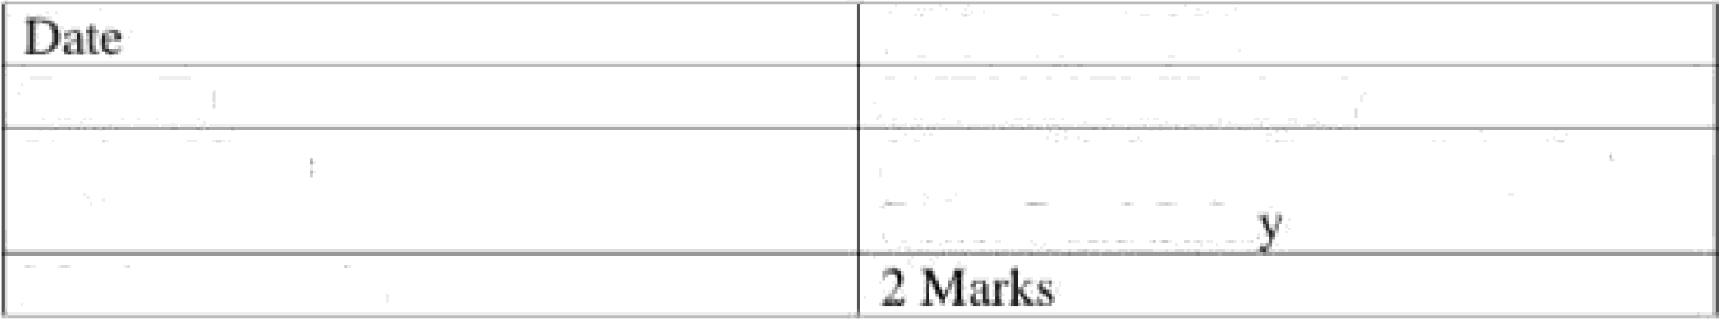

# PNT2022TMID05398

Signs with Smart Connectivity for

Better Road safety

Problem Statement :

